**SQL ASSIGNMENT**

**Query 1**

1. **Find out the SELLING COST AVERAGE for the packages developed in PASCAL?**

**Query:** SELECT AVG(scost) FROM sql_query.software WHERE dev_in LIKE 'Pascal'; 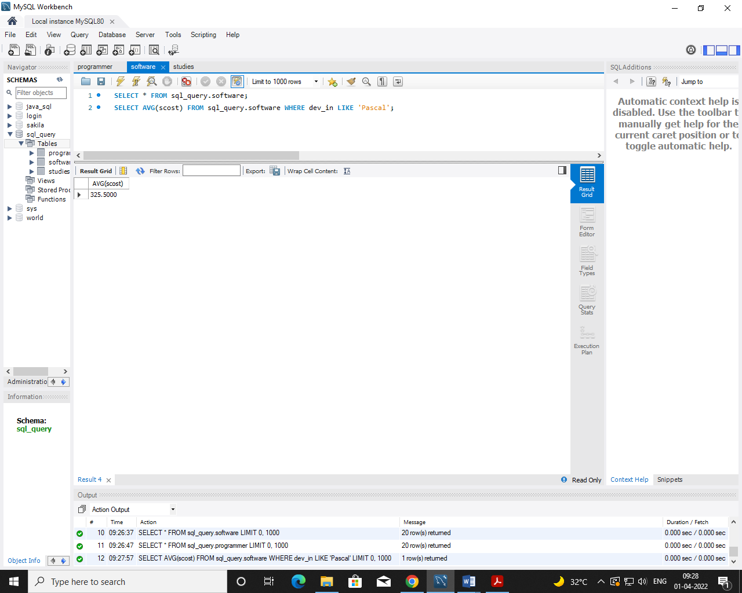

1. **Display the names and ages of all programmers.**

**Query:** SELECT name AS name, FLOOR(datediff(current_date,dob)/365) AS AGE FROM sql_query.programmer;

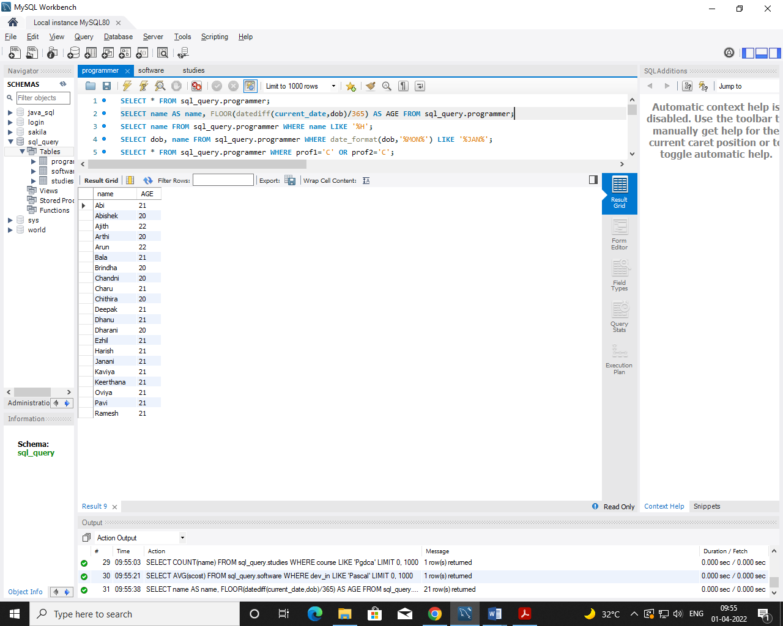

1. **Display the names and ages of all the programmers who have undergone training in DCS course.**

**Query:** SELECT P.name,FLOOR(datediff(current_timestamp,dob)/365) as age, course FROM sql_query.programmer p, sql_query.studies st WHERE p.name=st.name AND course LIKE 'Dcs';

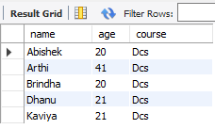

1. **What is the highest numbers of copies sold by a package?**

**Query:** SELECT MAX(sold) FROM sql_query.software;

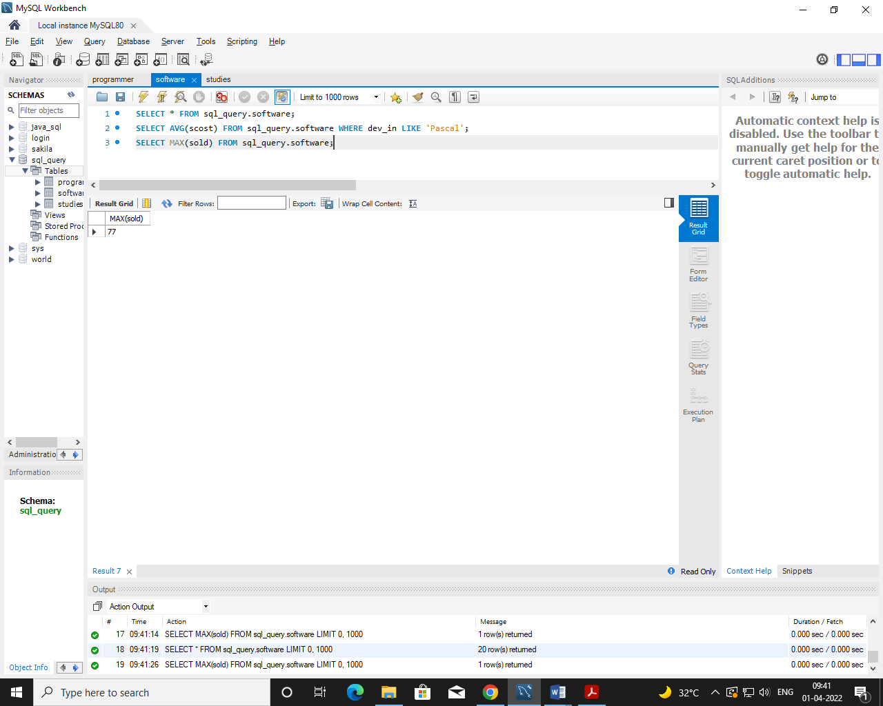

1. **Display the names and date of birth of all the programmer born in JANUARY.**

**Query:** SELECT dob, name FROM sql_query.programmer WHERE date_format(dob,'%MON%') LIKE '%JAN%';

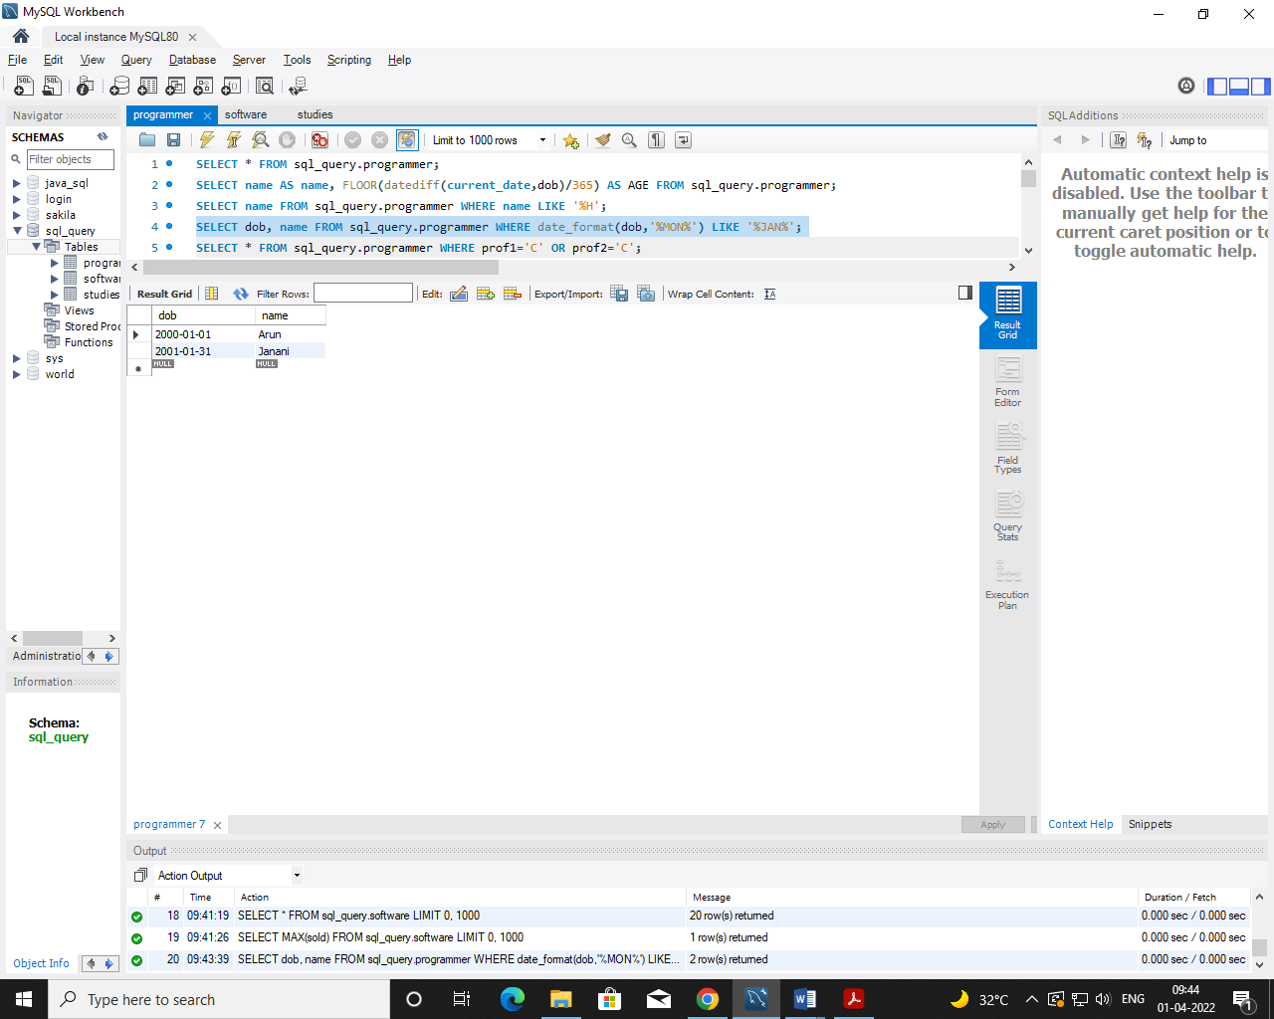

1. **Display lowest course fee.**

**Query:** SELECT MIN(ccost) FROM sql_query.studies;

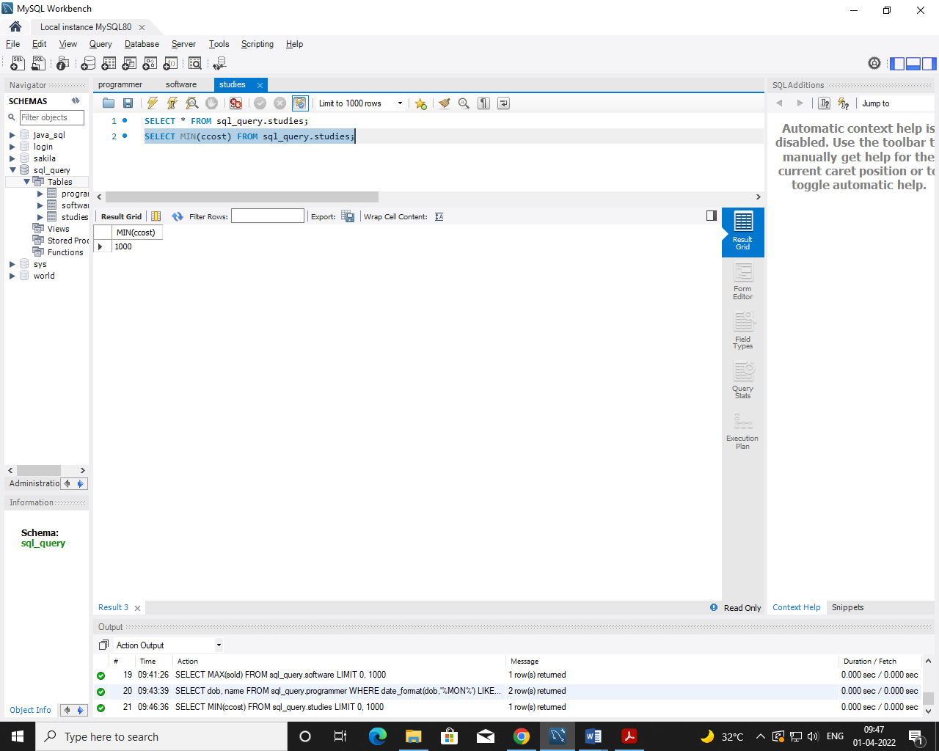

1. **How many programmer has done PGDCA course.**

**Query:** SELECT COUNT(name) FROM sql_query.studies WHERE course LIKE 'Pgdca';

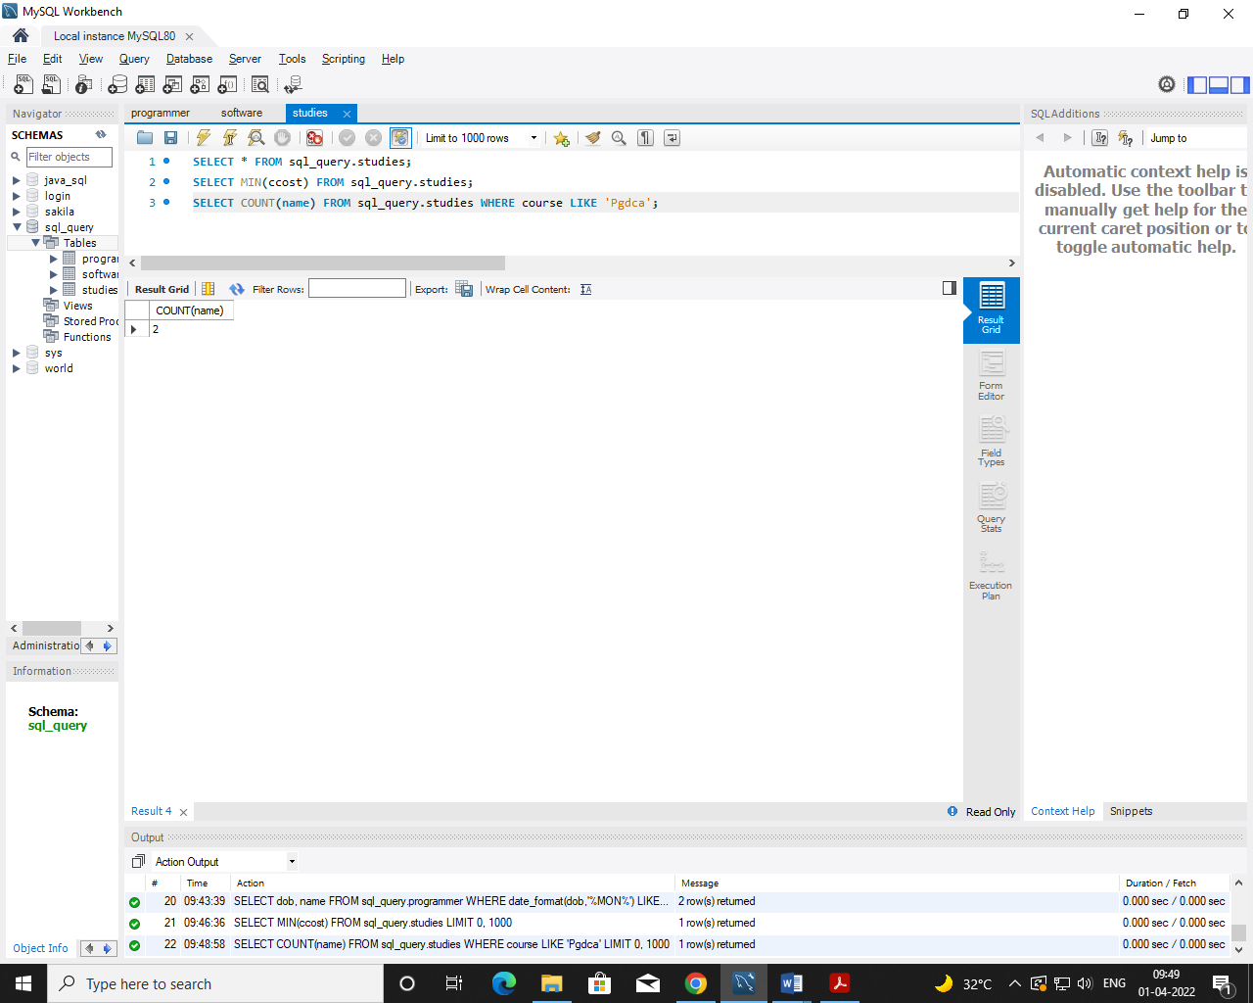

1. **How much revenue has been earned through sales of packages in C.**

**Query:** SELECT SUM(sold*scost) FROM sql_query.software WHERE dev_in LIKE 'C';

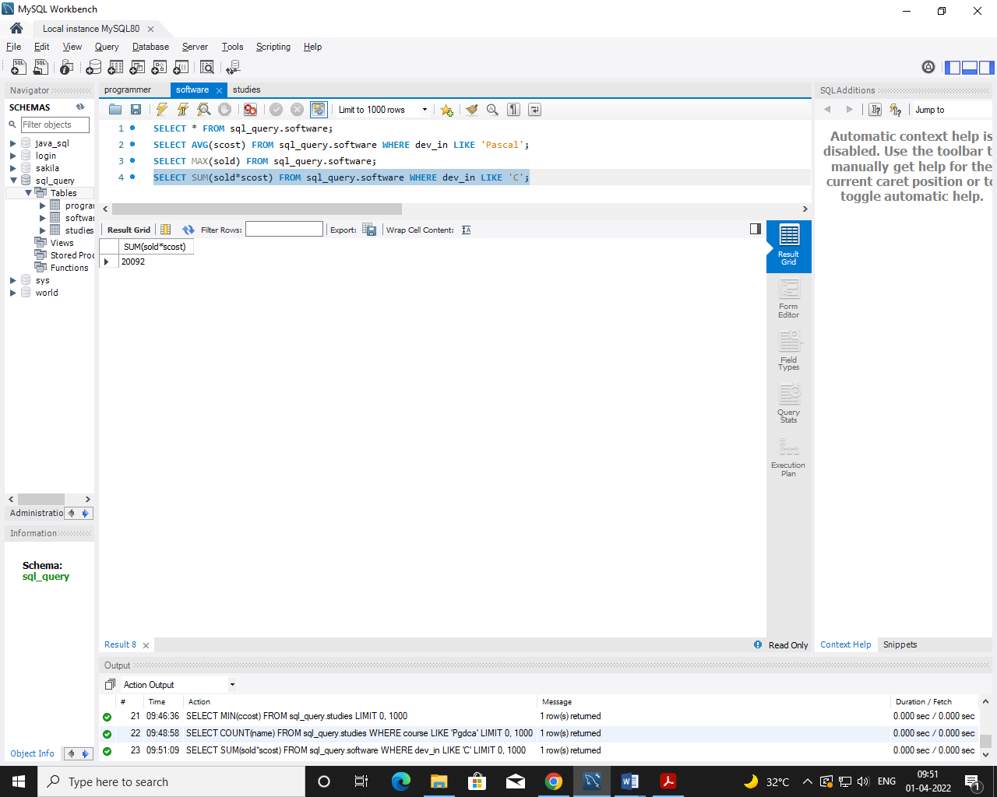

1. **Display the details of software developed by Ramesh?**

**Query:** SELECT * FROM sql_query.software WHERE name='Ramesh';

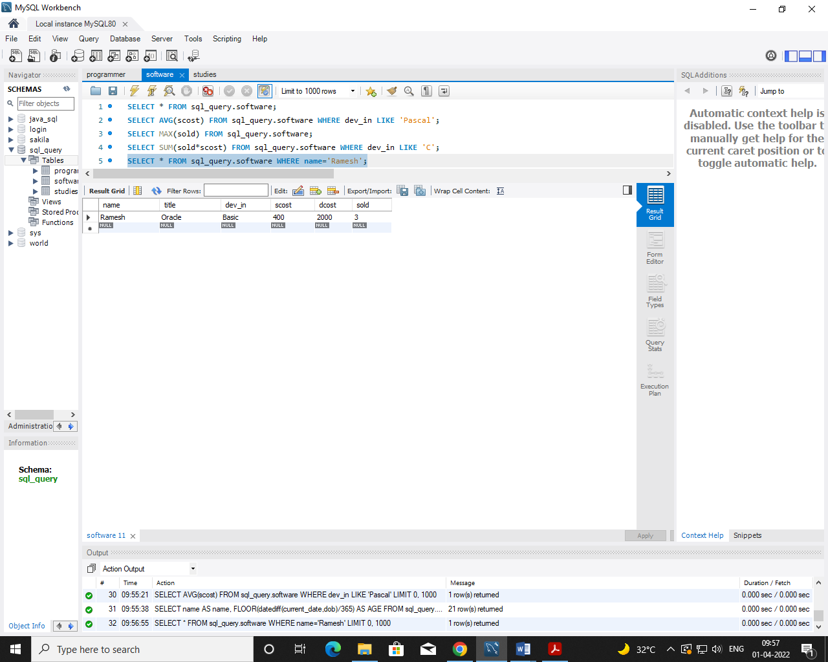

1. **How many programmers studied at Sabhari.**

**Query:** SELECT COUNT(name) AS NOPROGRAMMERS FROM sql_query.studies WHERE splace='Sabhari';

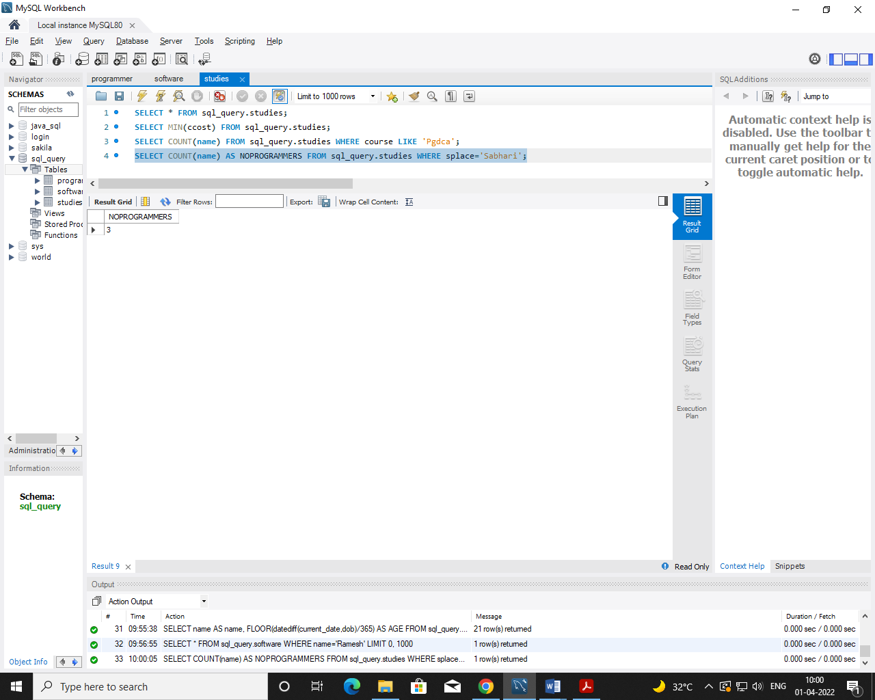

1. **Display the details of PACKAGES whose sales crossed the 20000 mark.**

**Query:** SELECT * FROM sql_query.software WHERE (sold*scost)>20000;

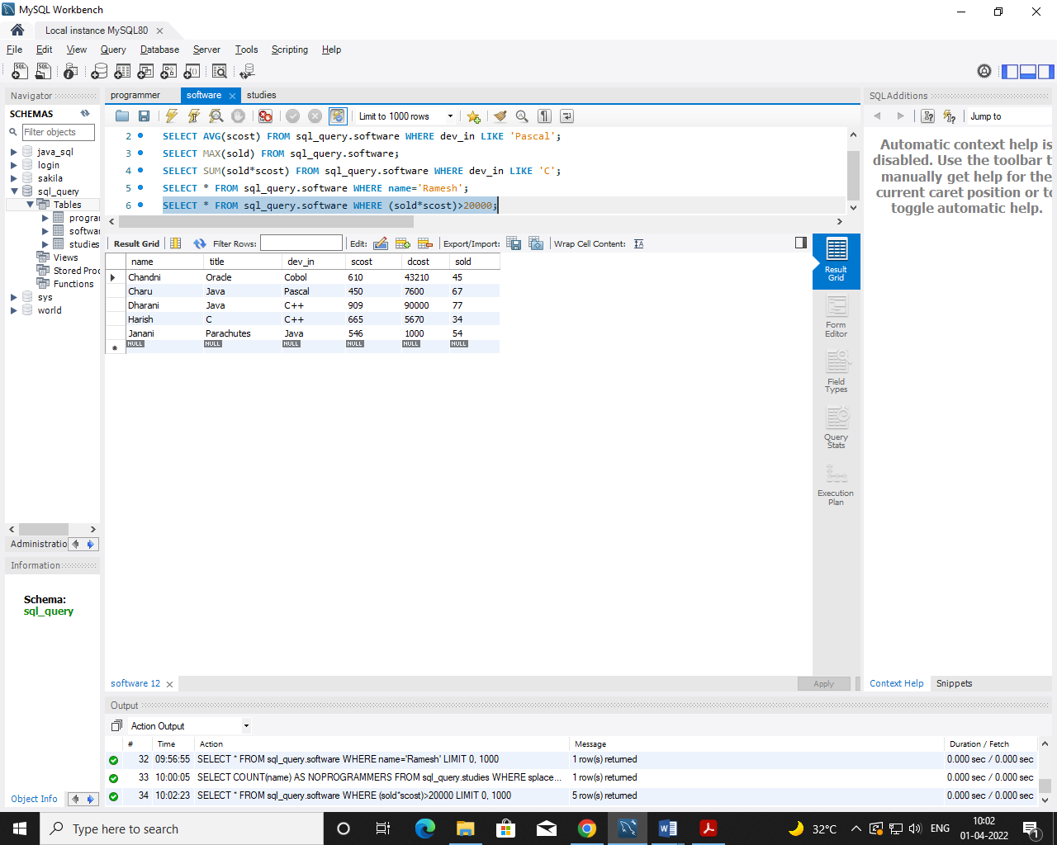

1. **Find out the number of copies which should be sold in order to recover the development cost of each package.**

**Query:** SELECT ROUND(dcost/scost) FROM sql_query.software WHERE scost*sold<dcost;

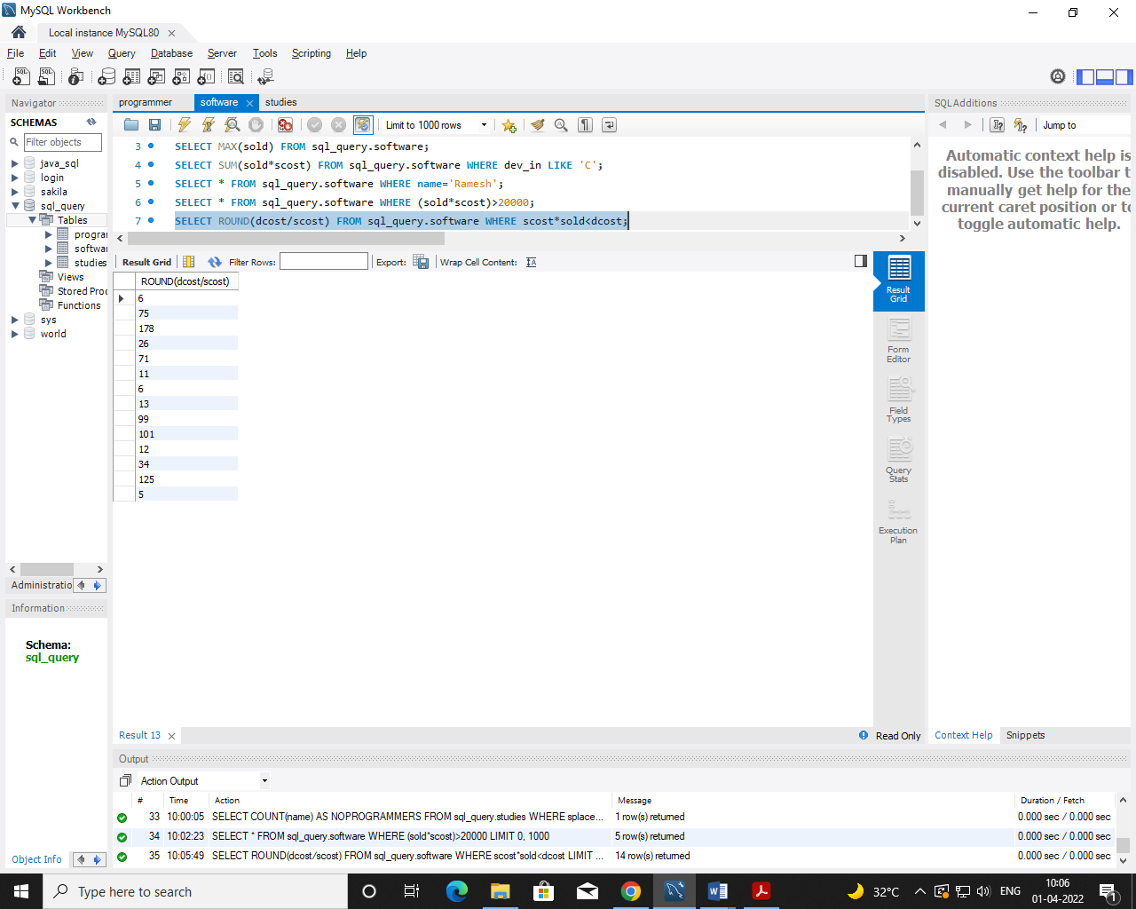

1. **What is the price of the costliest software developed in Basic?**

**Query:** SELECT MAX(scost) FROM sql_query.software WHERE dev_in LIKE 'Basic';

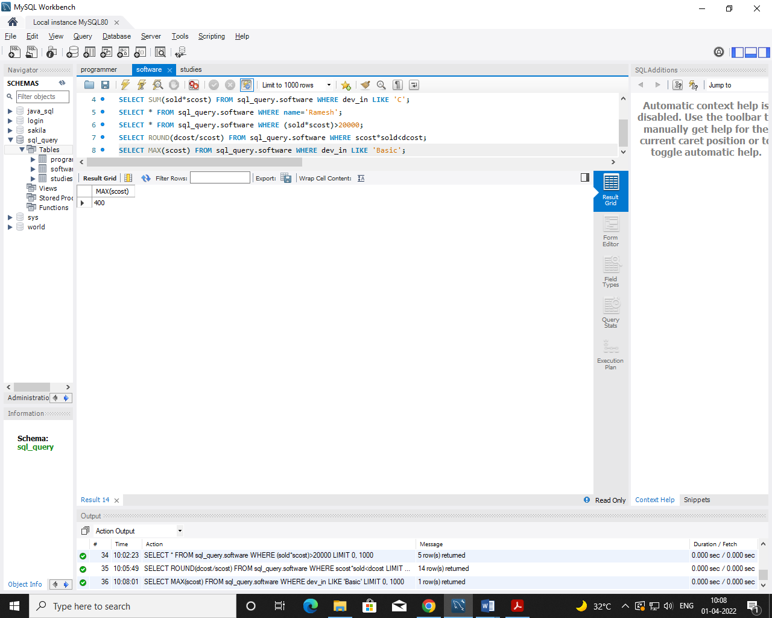

1. **Display the details of packages for which development cost has been recovered.**

**Query:** SELECT * FROM sql_query.software WHERE (sold*scost)>dcost;

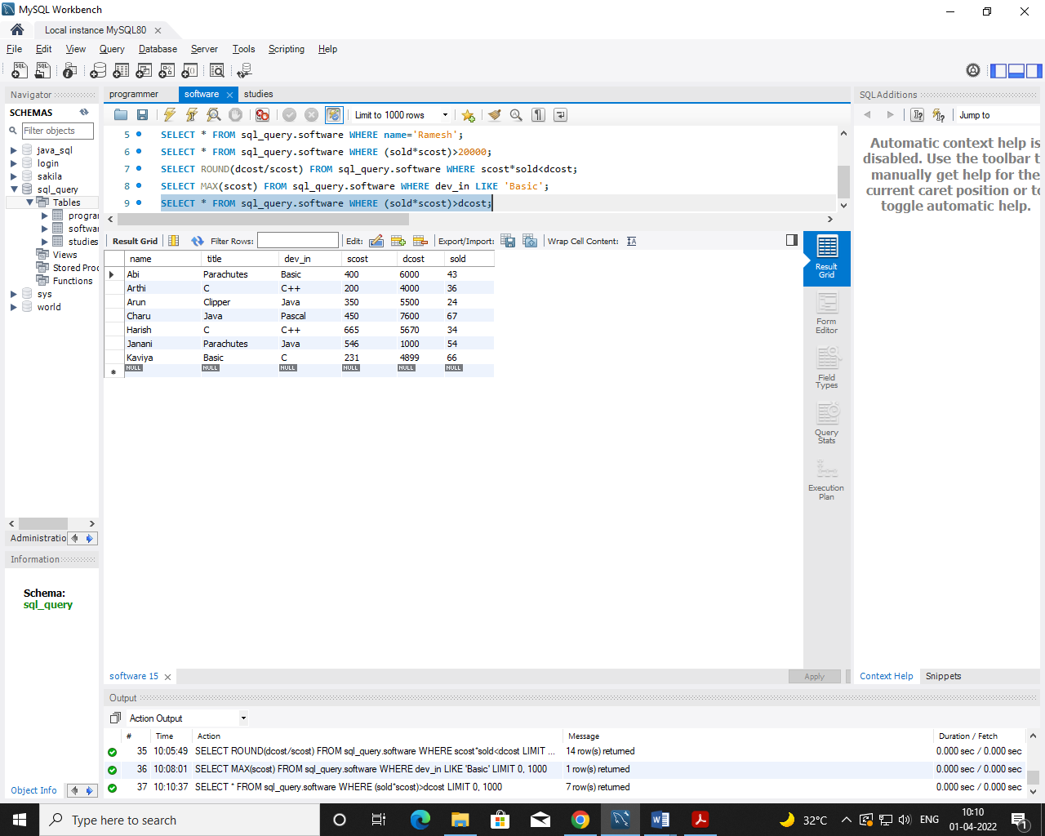

1. **How many packages were developed in dbase?**

**Query:** SELECT COUNT(title) AS TOTAL FROM sql_query.software WHERE dev_in='Dbase';

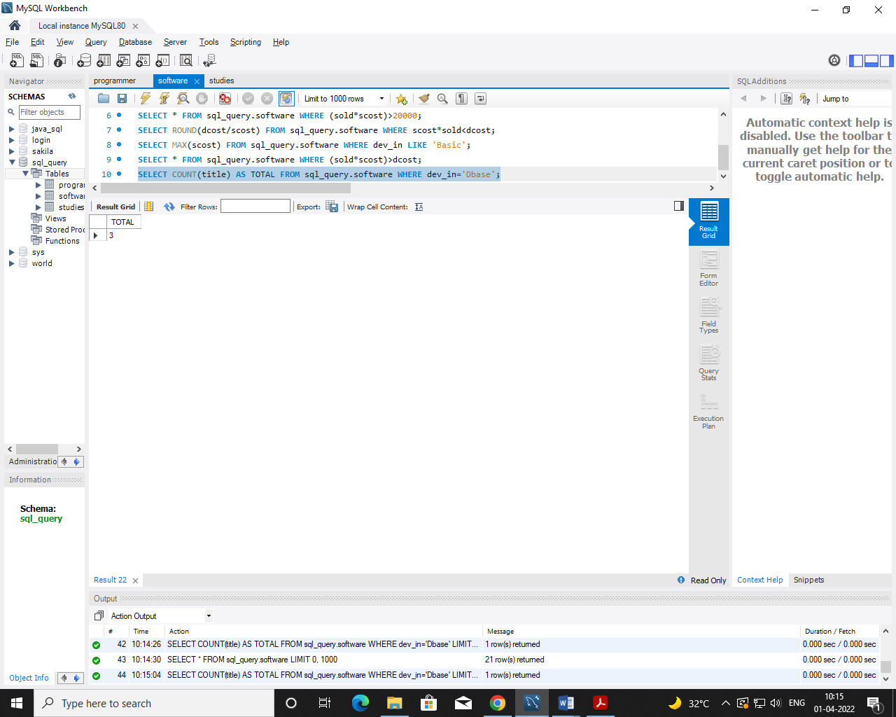

1. **How many programmers studies at paragathi?**

**Query:** SELECT COUNT(name) FROM sql_query.studies WHERE splace='Pragathi';

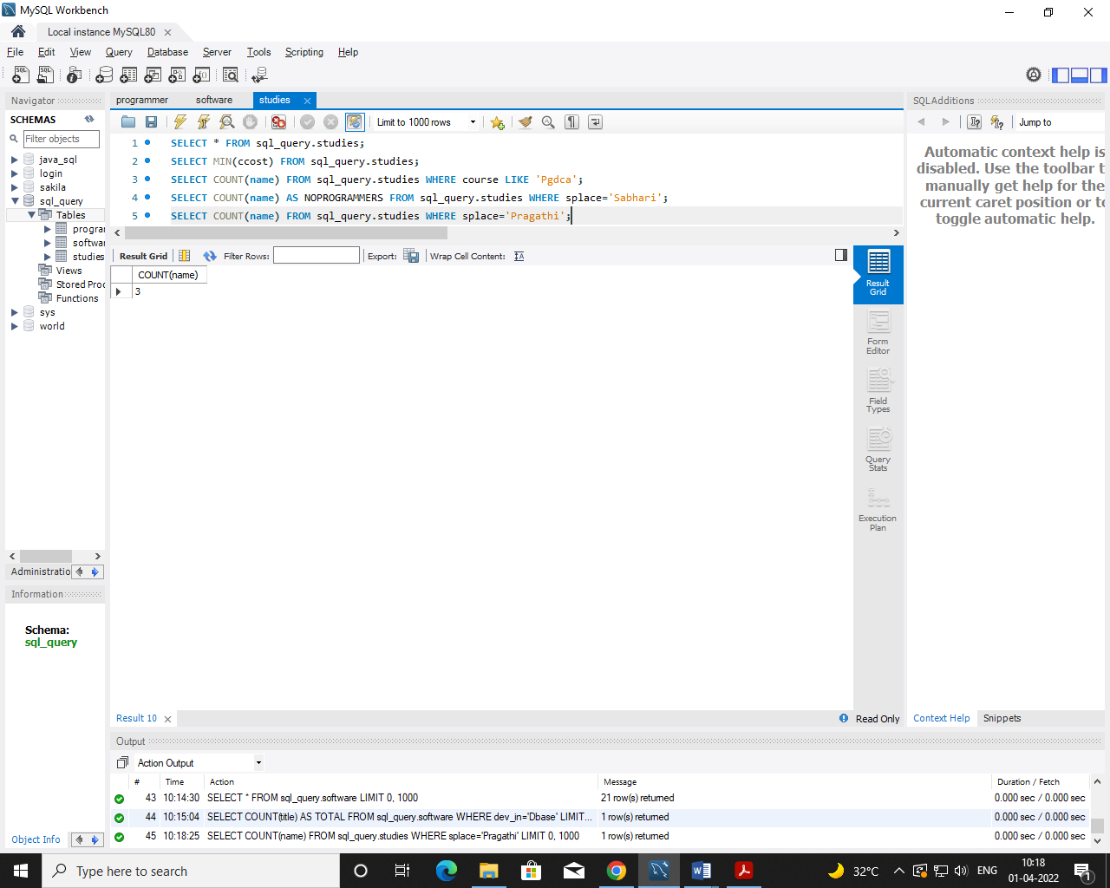

1. **How many programmers paid 5000 to 10000 for their course?**

**Query:** SELECT COUNT(name) AS NO_OF_PROGRAMMERS FROM sql_query.studies WHERE ccost>=5000 AND ccost<=10000;

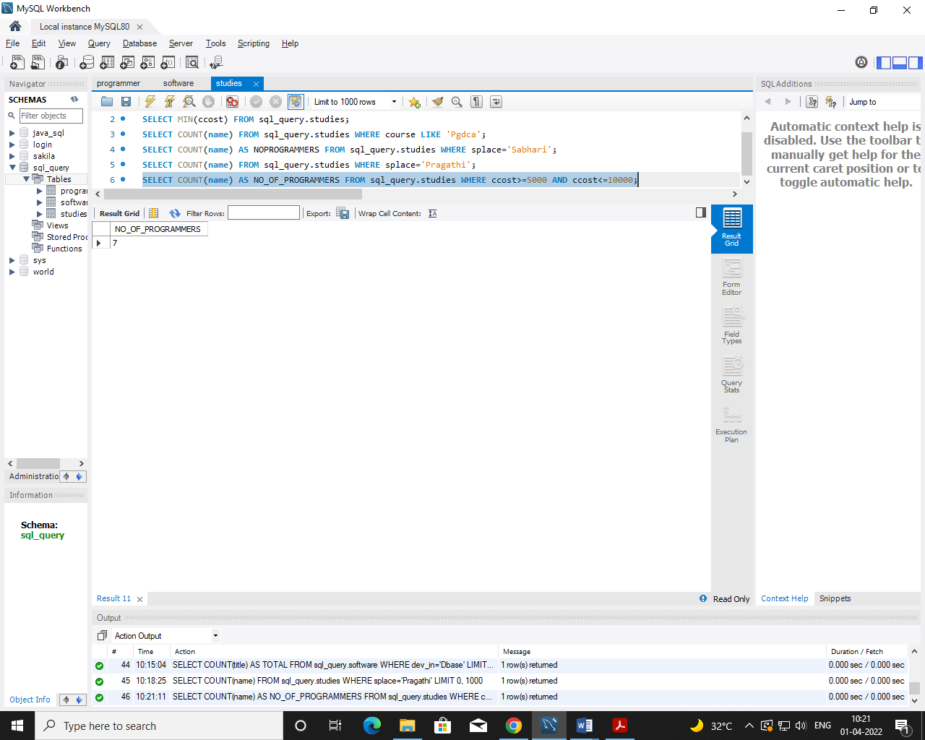

1. **What is the average course fee?**

**Query:** SELECT AVG(ccost) AS AVERAGECOST FROM sql_query.studies;

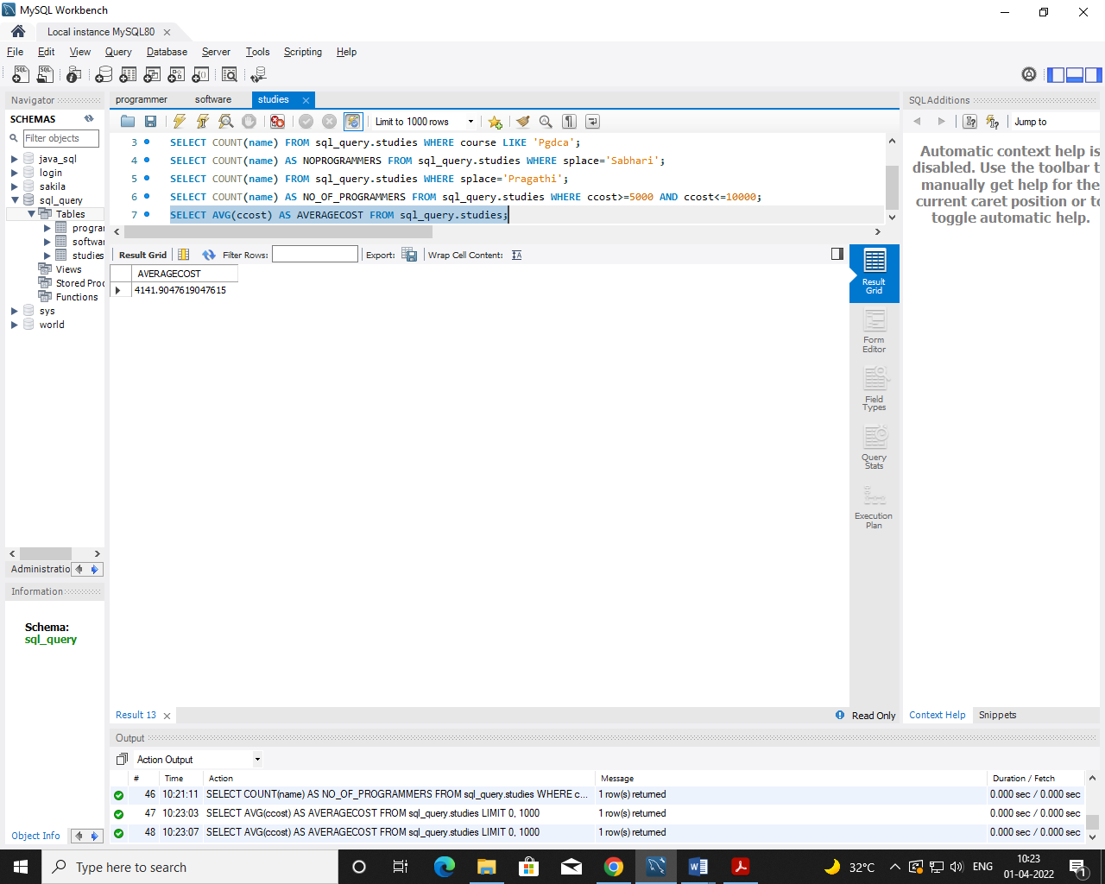

1. **Display the details of programmers knowing c?**

**Query:** SELECT * FROM sql_query.programmer WHERE prof1='C' OR prof2='C';

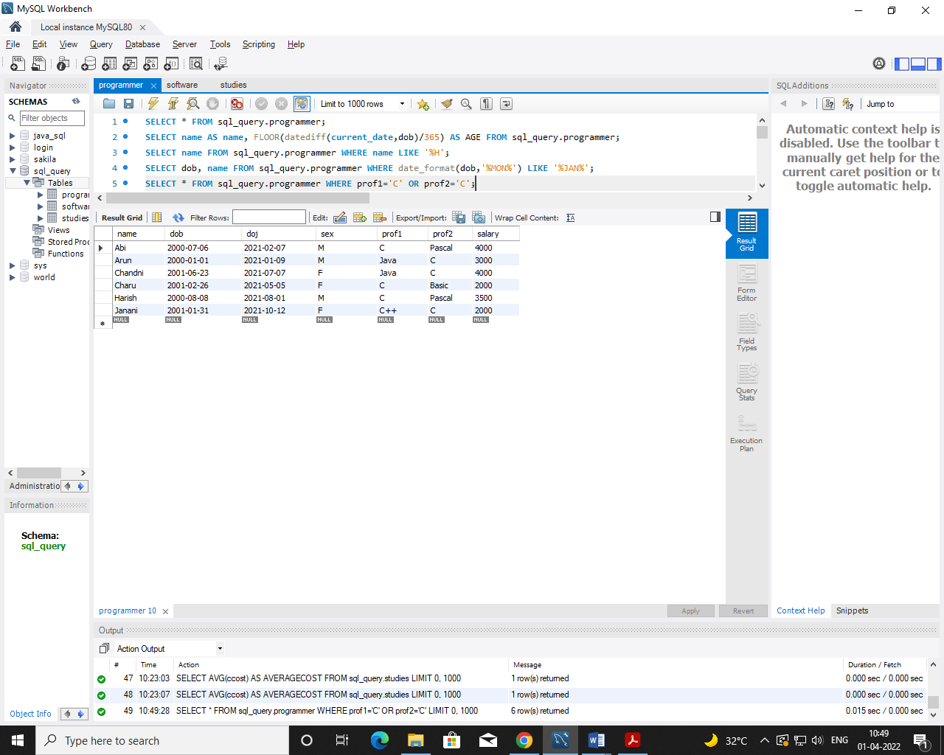

1. **How many programmers know either Cobol or Pascal?**

**Query:** SELECT COUNT(name) AS PROGRAMMERS FROM sql_query.programmer WHERE prof1 IN ('Cobal' ,'Pascal' ) OR prof2 IN ('Cobal' ,'Pascal' );

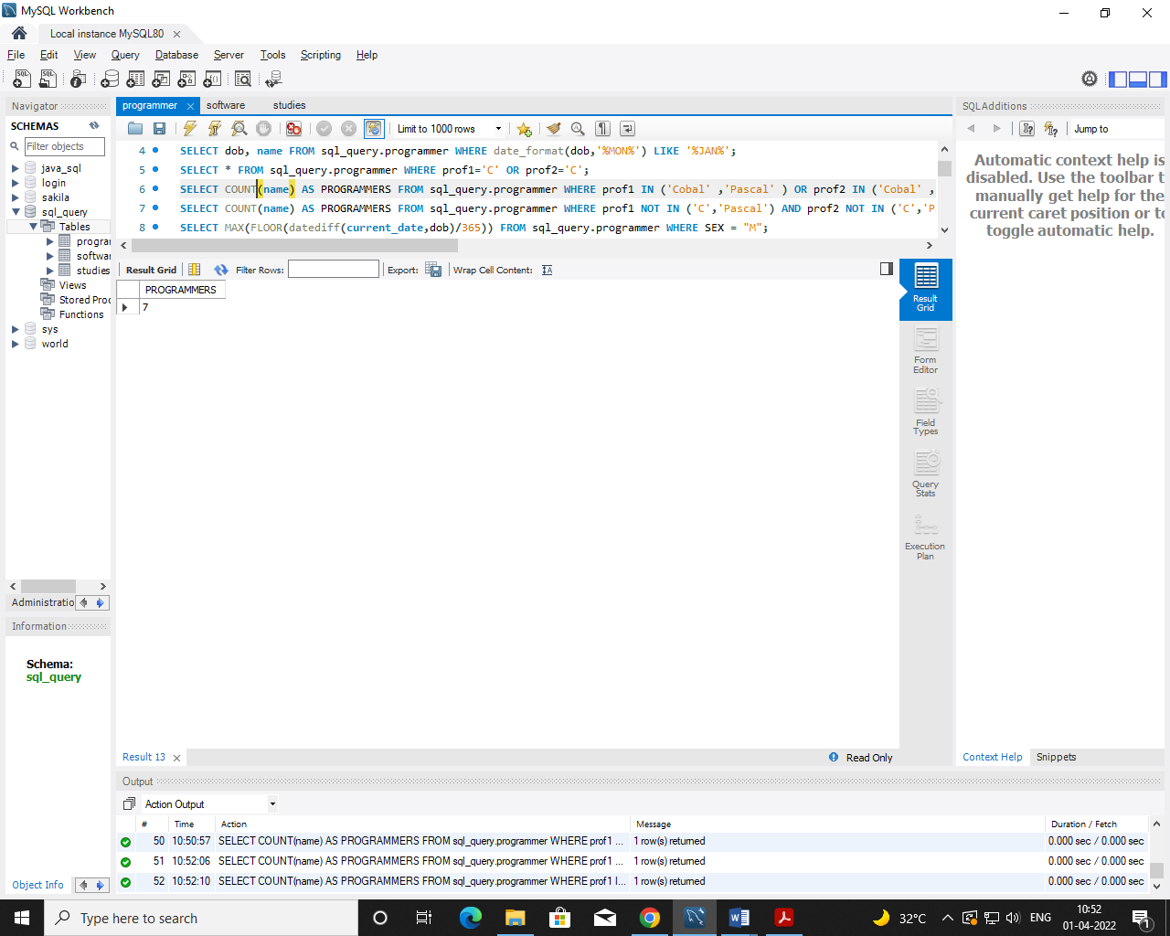

1. **How many programmers don't know Pascal & C?**

**Query:** SELECT COUNT(name) AS PROGRAMMERS FROM sql_query.programmer WHERE prof1 NOT IN ('C','Pascal') AND prof2 NOT IN ('C','Pascal');

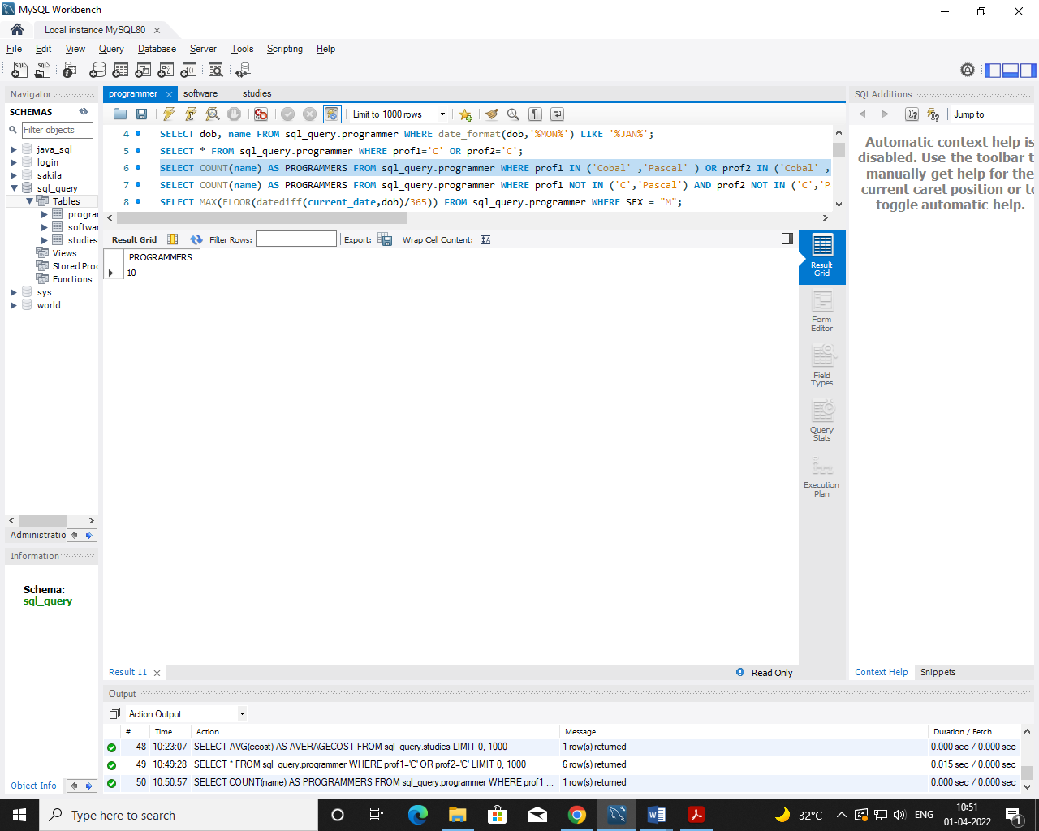

1. **How old is the oldest male programmers?**

**Query:** SELECT MAX(FLOOR(datediff(current_date,dob)/365)) FROM sql_query.programmer WHERE SEX = "M";

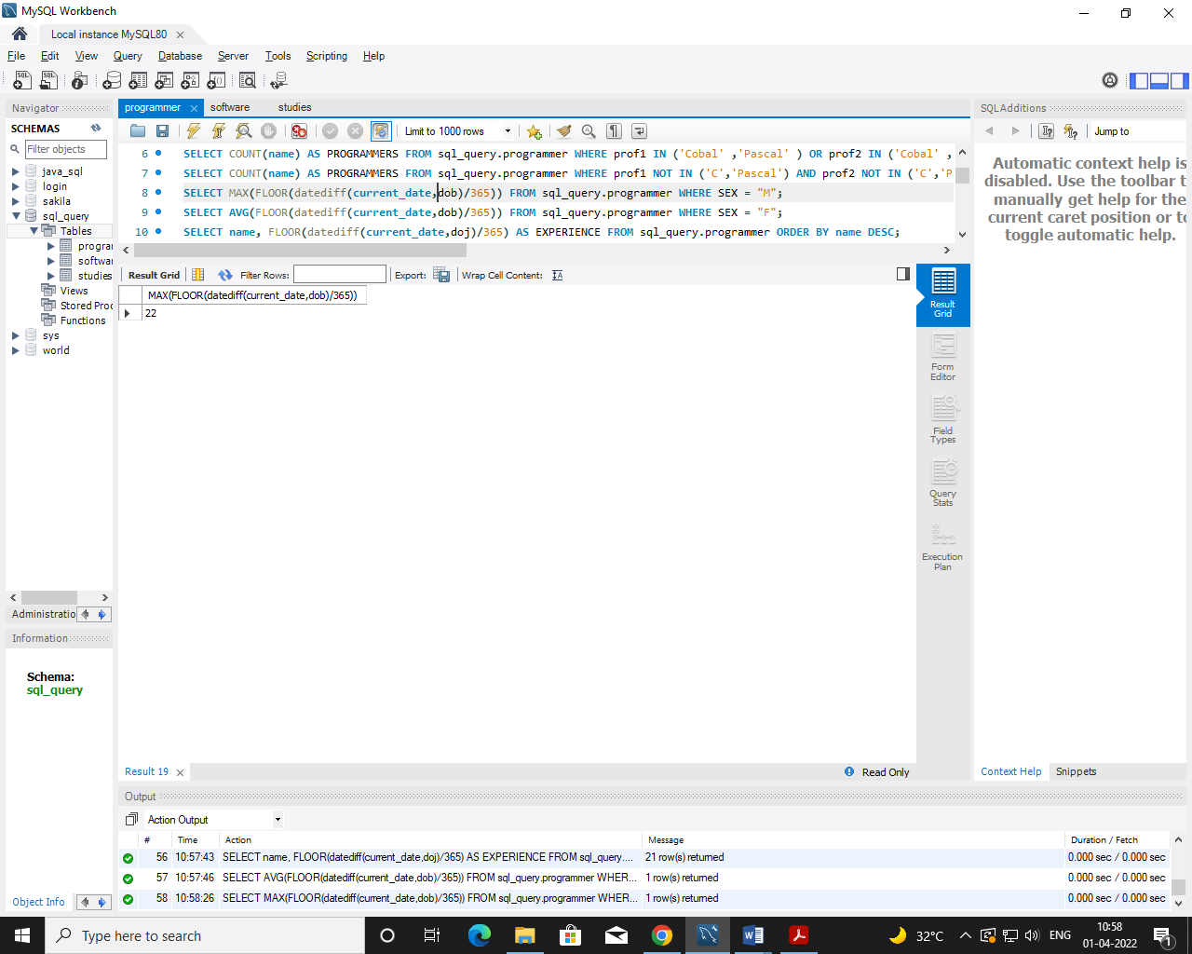

1. **What is the average age of female programmers?**

**Query:** SELECT AVG(FLOOR(datediff(current_date,dob)/365)) FROM sql_query.programmer WHERE SEX = "F";

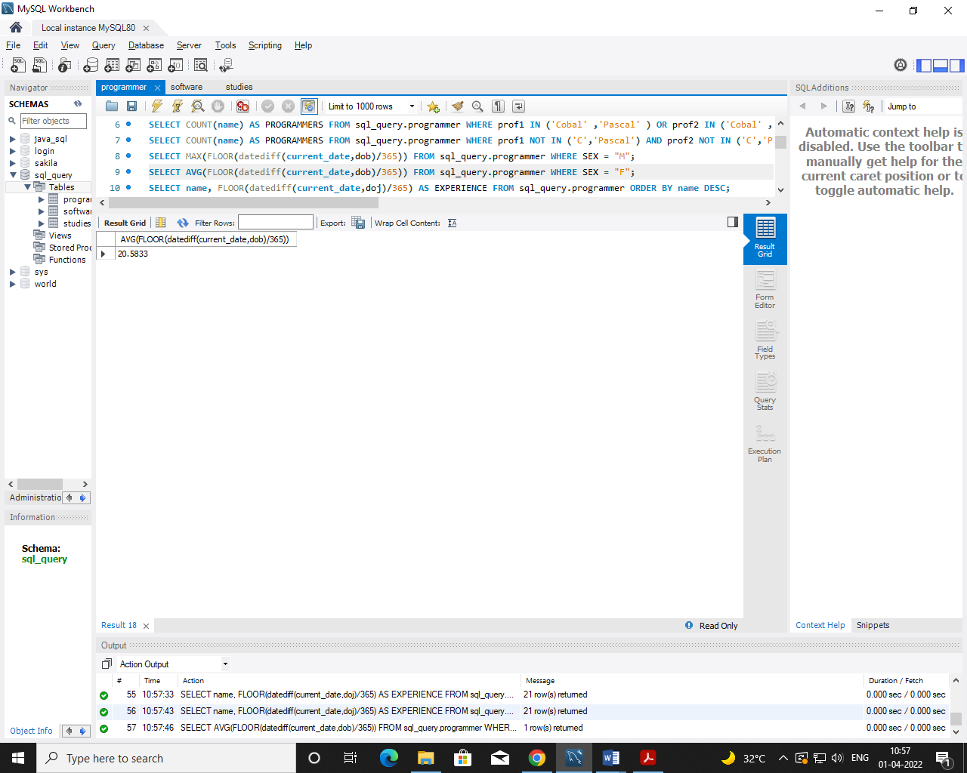

1. **Calculate the experience in years for each programmers and display along with the names in descending order?**

**Query**: SELECT name, FLOOR(datediff(current_date,doj)/365) AS EXPERIENCE FROM sql_query.programmer ORDER BY name DESC;

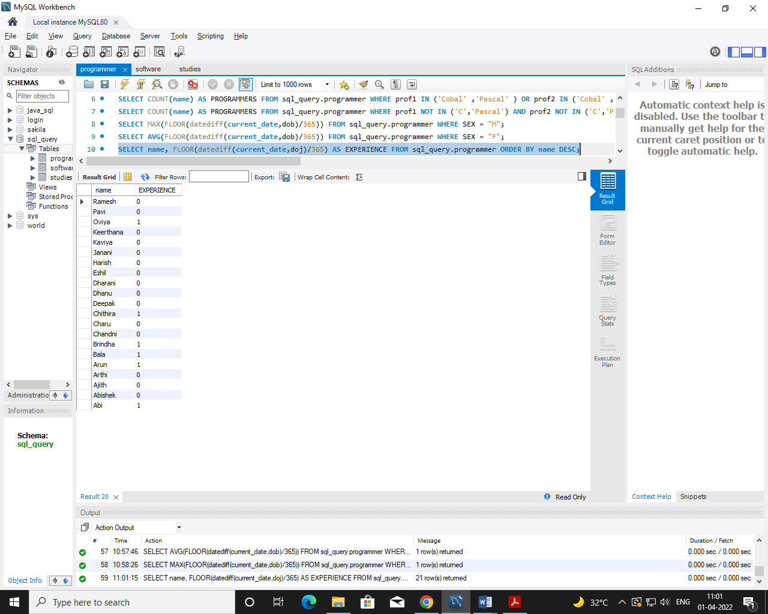

1. **Who are the programmers who celebrate their birthday during the current month?**

**Query**: SELECT name FROM sql_query.programmer WHERE date_format (dob,'%M') = date_format(current_timestamp,'%M');

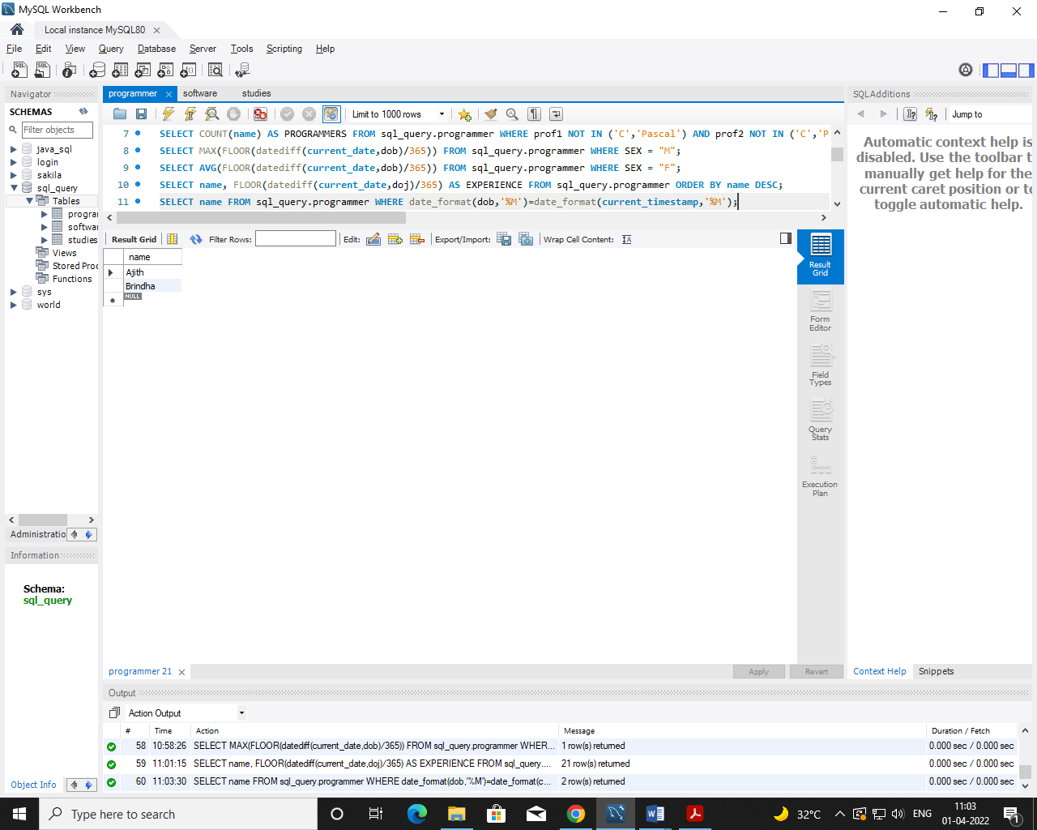

1. **How many female programmers are there?**

**Query:** SELECT COUNT(name) FEMALE_PROG FROM sql_query.programmer WHERE sex='F';

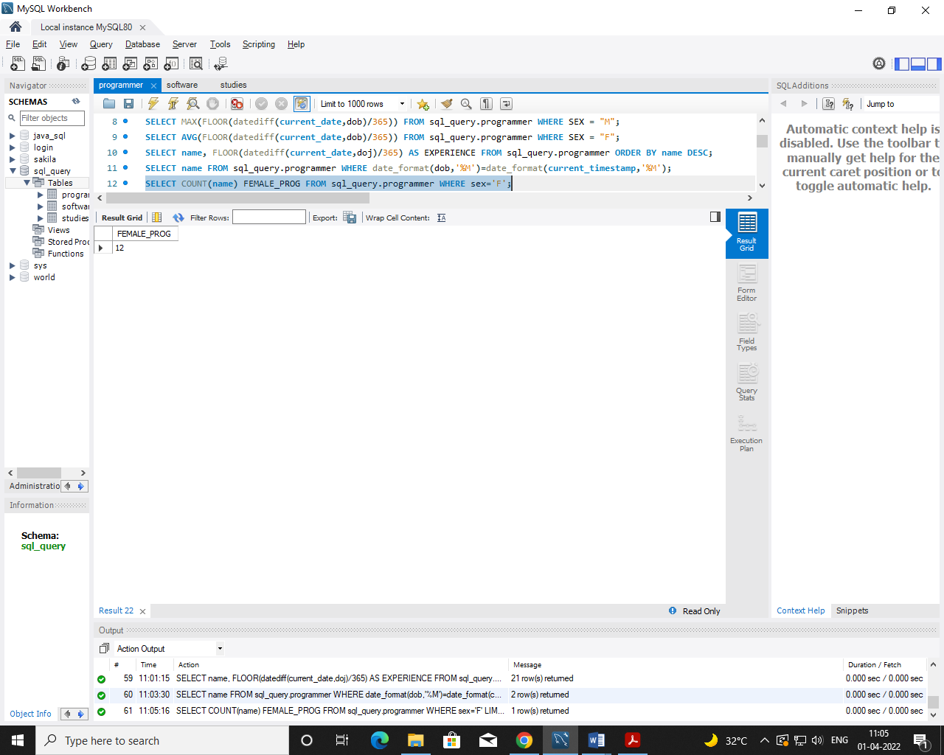

1. **What are the languages known by the male programmers?**

**Query:** SELECT DISTINCT prof1 LANGUAGES FROM sql_query.programmer WHERE sex = 'M' UNION SELECT DISTINCT prof2 FROM sql_query.programmer WHERE sex ='M';

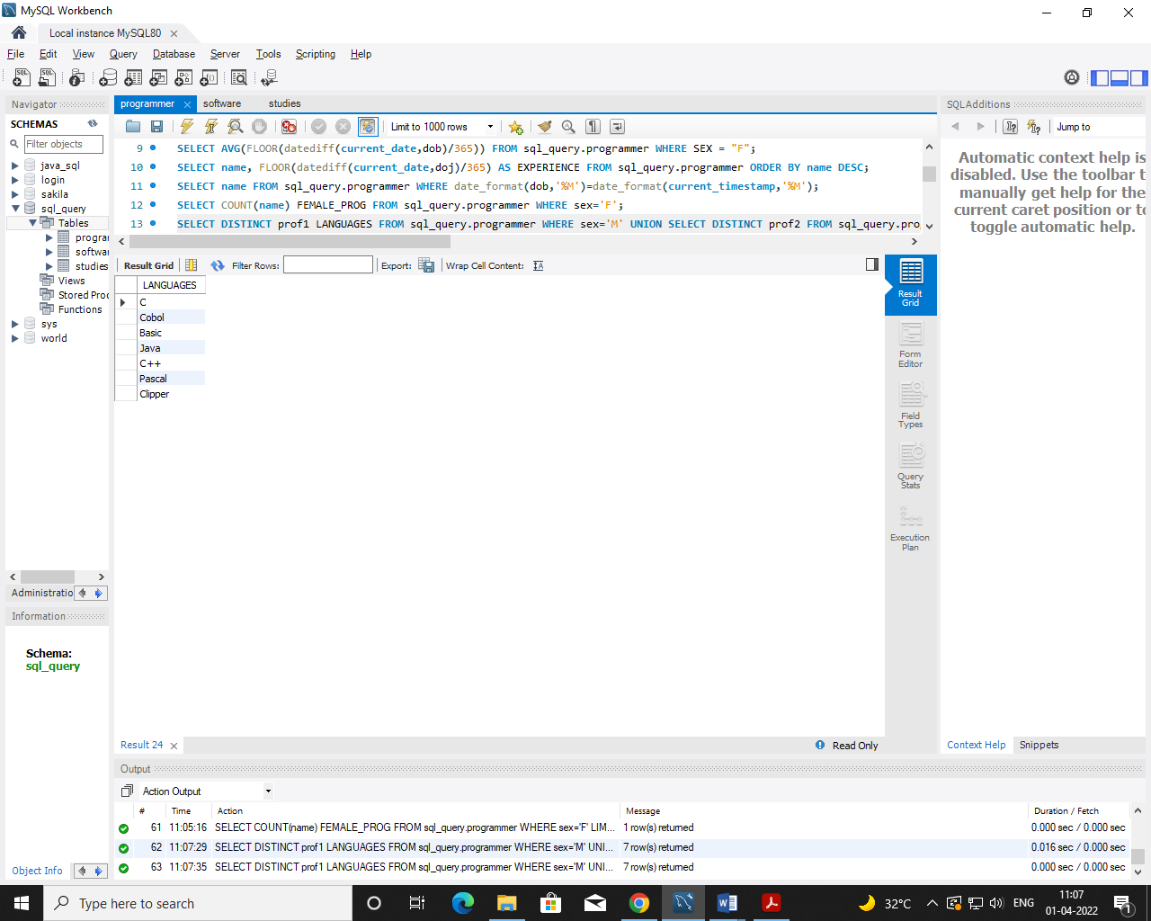

1. **What is the Average salary?**

**Query:** SELECT AVG(salary) AS AVGSAL FROM sql_query.programmer;

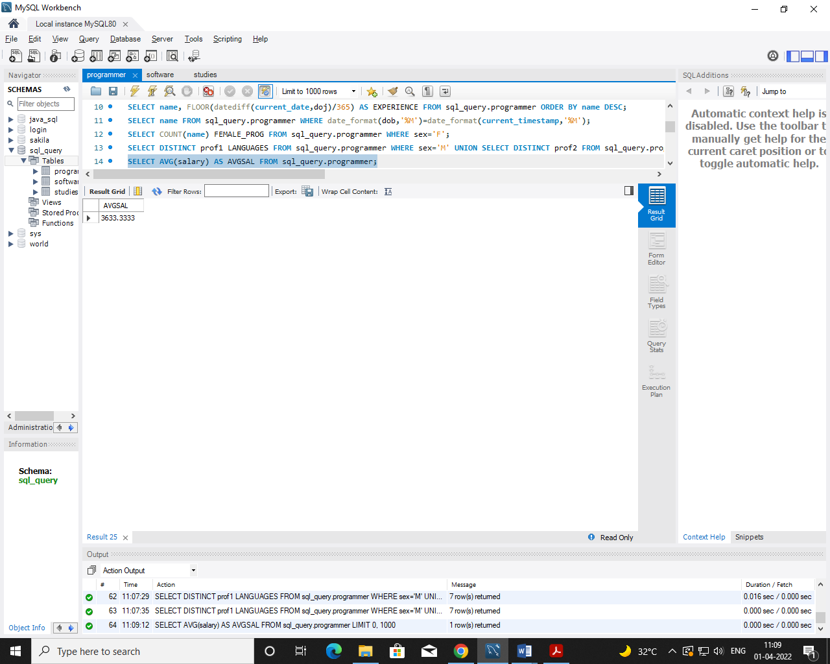

1. **How many people draw 2000 to 4000?**

**Query:** SELECT name FROM sql_query.programmer WHERE salary BETWEEN 2000 AND 4000;

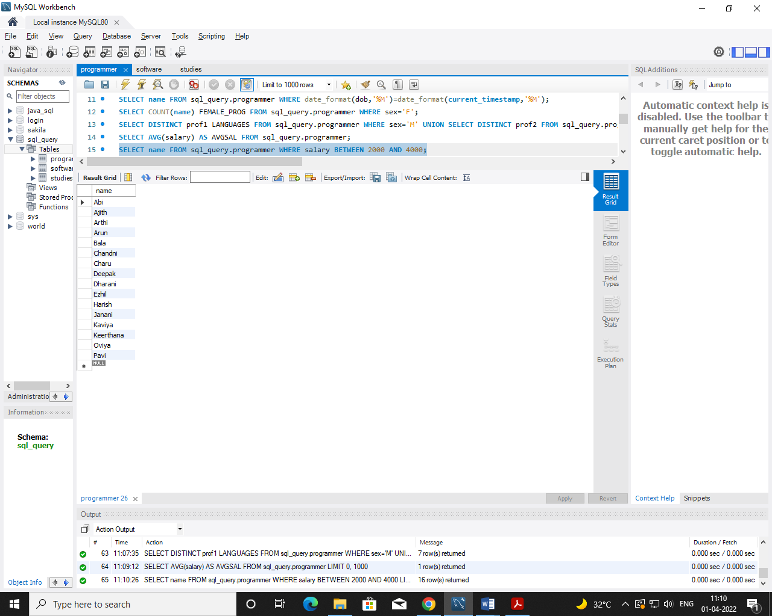

1. **Display the details of those who don't know Clipper, Cobol or Pascal?**

**Query:** SELECT * FROM sql_query.programmer WHERE prof1 NOT IN ('Clipper','Cobol','Pascal') AND prof2 NOT IN ('Clipper','Cobol','Pascal');

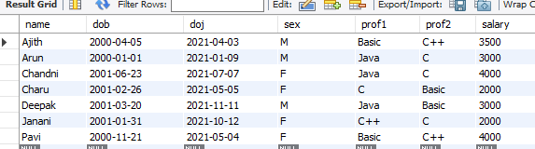

1. **How many Female programmers knowing C are above 24 years of age?**

**Query:** SELECT COUNT(name) FROM sql_query.programmer WHERE sex='F' AND (prof1='C' OR prof2='C') AND ((current_date-DOB)/365) > 24;

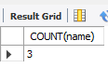

1. **Who are the programmers who will be celebrating their Birthday within a week?**

**Query:** SELECT name FROM sql_query.programmer WHERE date_format(dob,'%W') = date_format(current_timestamp,'%W');

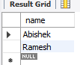

1. Display the details of those with less than a year's experience?

**Query:** SELECT * FROM sql_query.programmer WHERE FLOOR (datediff (current_date ,doj)/365)<1;

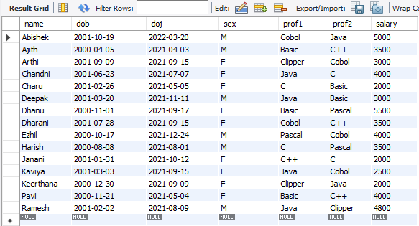

1. Display the details of those who will be completing 2 years of service this year?

**Query:** SELECT name FROM sql_query.programmer WHERE FLOOR(datediff(current_date,doj)/365)=2;

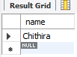

1. Calculate the amount to be recovered for those packages whose development cost has not been recovered?

**Query:** SELECT (dcost-(scost*sold)), title FROM sql_query.software WHERE (scost*sold)<dcost;

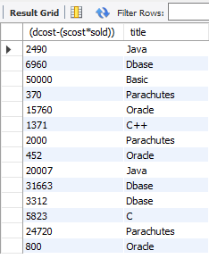

1. List the packages which have not been sold so far?

**Query:** SELECT title SOFTWARE FROM sql_query.software WHERE sold=0;

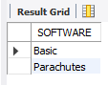

1. Find out the cost of the software developed by Mary?

**Query:** SELECT title, scost AS SOFTCOST FROM sql_query.software WHERE name='MARY';

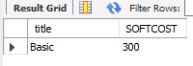

1. Display the institute’s names from the studies table without duplicates?

**Query:** SELECT DISTINCT splace FROM sql_query.studies;

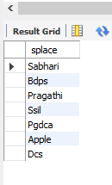

1. How many different courses are mentioned in the studies table?

**Query:** SELECT DISTINCT course FROM sql_query.studies;

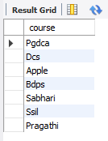

1. Display the names of the programmers whose names contain 2 occurrences of the letter A?

**Query:** SELECT name FROM sql_query.programmer WHERE name LIKE '%A%A%';

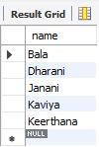

1. Display the names of programmers whose names contain unto 5 characters?

**Query:** SELECT name FROM sql_query.programmer WHERE LENGTH(name)=5;

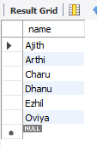

1. How many female programmers knowing COBOL have more than 2 years experience?

**Query:** SELECT name FROM sql_query.programmer WHERE FLOOR((current_date-doj)/365)>2 AND sex='F' AND (prof1='Cobol' OR prof2='Cobol');

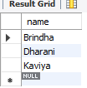

1. What is the length of the shortest name in the programmer table?

**Query:** SELECT MIN(LENGTH(name)) FROM sql_query.programmer;

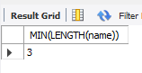

1. What is the average development cost of a package developed in COBOL?

**Query:** SELECT AVG(dcost) FROM sql_query.software WHERE dev_in='Cobol';

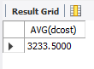

1. Display the name, sex, dob (DD/MM/YY format), doj for all the programmers without using conversion function?

**Query:** SELECT name, sex , SUBSTR(dob,1,2)|| '/'||SUBSTR(dob,4,3)||'/'||SUBSTR(dob,8,2) dob,SUBSTR(doj,1,2)||'/'||SUBSTR(doj,4,3)||'/'||SUBSTR(doj,8,2) doj FROM sql_query.programmer;

1. Who are the programmers who were born on the last day of the month?

**Query:** SELECT name FROM sql_query.programmer WHERE LAST_DAY(dob) = dob;

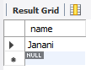

1. What is the amount paid in salaries of the male programmers who do not know Cobol?

**Query:** SELECT salary FROM sql_query.programmer WHERE sex='M' AND (prof1!='Cobol' OR prof2!='Cobol');

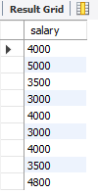

1. Display the title, scost, dcost and difference between scost and dcost in descending order of difference?

**Query:** SELECT title, scost, dcost, dcost - scost DIFF FROM sql_query.software ORDER BY 4 DESC;

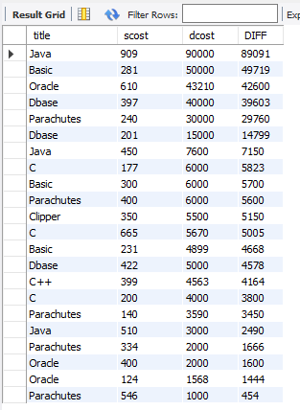

1. Display the name, dob, doj of those month of birth and month of joining are same?

**Query:** SELECT name FROM sql_query.programmer WHERE date_format(dob,'%M%')= date_format(doj,'%M%');

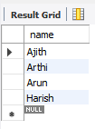

1. Display the names of the packages whose names contain more than 1 word?

**Query:** SELECT title FROM sql_query.software WHERE title LIKE '% %';

